Coffee & Bean

Continuous Assessment 2 (CA-2)

Danielle Caroline da S. Medeiros - 23385731

Deysemare Menezes Santos - 23157607

Vinícius Araújo dos Santos - 23409622

HDCSDEV_INT - Web Design and Client-Side Scripting

Higher Diploma in Science in Computing

**29 November 2024**

Eugene McLaughlin

**Index**

1. Project Summary 1

2. Collaborative effort 2

3. Design Process 3

3.1. Wireframe 3

4. Development 9

4.1. Bootstrap 9

4.2. jQuery 10

4.3. JavaScript 11

4.4. Testing & Evidence 12

5. Reviews 27

6. Conclusion 28

7. References 29

# Project Summary

We chose the Coffee Shop theme because of our passion for coffee and its cultural significance, as well as its universal appeal. Coffee is more than a drink… It represents energy, comfort, and community, making it an ideal focus for our project.

The problem we aim to solve is the lack of a centralized, user-friendly platform where customers can know about the coffee making process, find detailed information about coffee services, and connect with the rich history of coffee. By offering a seamless online experience, we bridge the gap between curiosity and accessibility, enhancing the overall journey for coffee lovers.

The market for coffee is vast and ever-growing. According to *BrewSmartly*, Dublin is the second most coffee-obsessed capital in Europe, with 181 coffee shops per 100,000 people and an estimated 2 billion cups consumed daily. This demonstrates not only the love for coffee but also the immense potential for innovation in this space.

**Link of our website:** [**https://vinichevalier.github.io/Coffee-Bean/index.html**](https://vinichevalier.github.io/Coffee-Bean/index.html)

# Collaborative effort

Our team collaboratively decided to base our project on the theme of coffee. To ensure an equitable workload, we divided the six pages of the project into two types for each team member: one simpler, informational page, and one more complex page requiring user interaction or the creation of advanced elements.

After defining the responsibilities for each page, we distributed additional tasks—such as reviewing and maintaining the general CSS, debugging JavaScript, and assembling the final report to ensure that everyone contributed to all aspects of the project. This balanced approach prevented an unequal division of effort while fostering teamwork.

**Page Assignments and Deliverables:**

* Daniele: Responsible for the About Us and Coffee Stores pages.
* Deysemare: Responsible for the Home Page (index.html) and Contact Us pages.
* Vinícius: Responsible for the Our Grains and Bean Boutique pages.

Each page must adhere to the established layout and style guidelines, which include using general and individual-specific CSS files. Deliverables for each page also incorporate requirements like the use of Bootstrap, jQuery, and JavaScript.

**Tools and Workflow:**

To manage the project efficiently, we utilized:

* **Trello** for activity mapping, task distribution, and progress tracking.
* **GitHub** for deployment and synchronization of individual contributions.
* **Visual Studio Code** for coding, leveraging its integration with GitHub to streamline collaboration

**Milestones:**

1. Page Design Completion: Layouts and wireframes finalized.
2. Coding Phase: HTML, CSS, and JavaScript implementation for each page.
3. Testing and Review: Collaborative testing of functionality and design consistency.
4. Final Submission: Assembling the report and deploying the final version.

This approach ensured a structured workflow with clear deliverables and milestones, while fostering collaboration across all project stages.

# Design Process

To design our site, we started by researching Irish coffee shop websites to understand the prevailing styles and identify elements that resonated with our project’s theme. Additionally, we explored other websites with visually appealing designs to gather broader inspiration. Based on our findings, we created several drafts, refining them collaboratively until we reached a design that satisfied everyone in the group. After finalizing the concept, we developed detailed wireframes for each page. These wireframes served as a blueprint, ensuring consistency across the layout and streamlining the design process for all group members.

## Wireframe

### Index

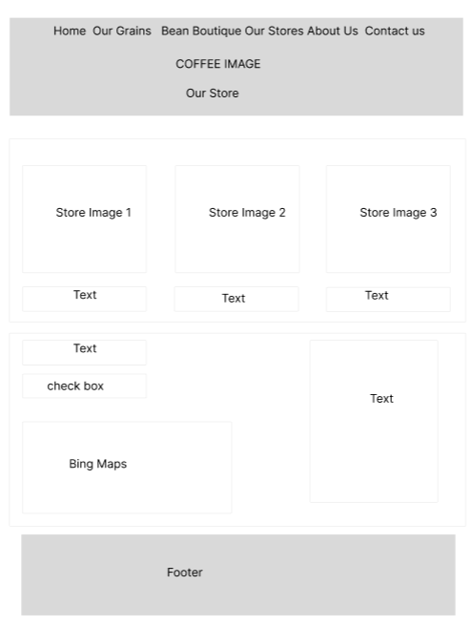

### Our Grains

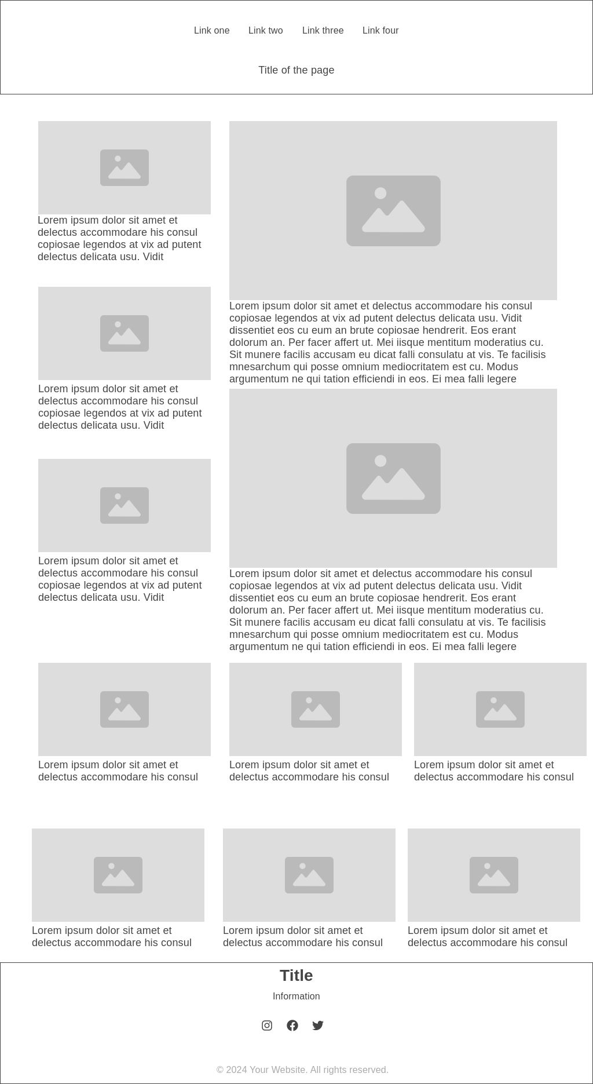

### Beans Boutique

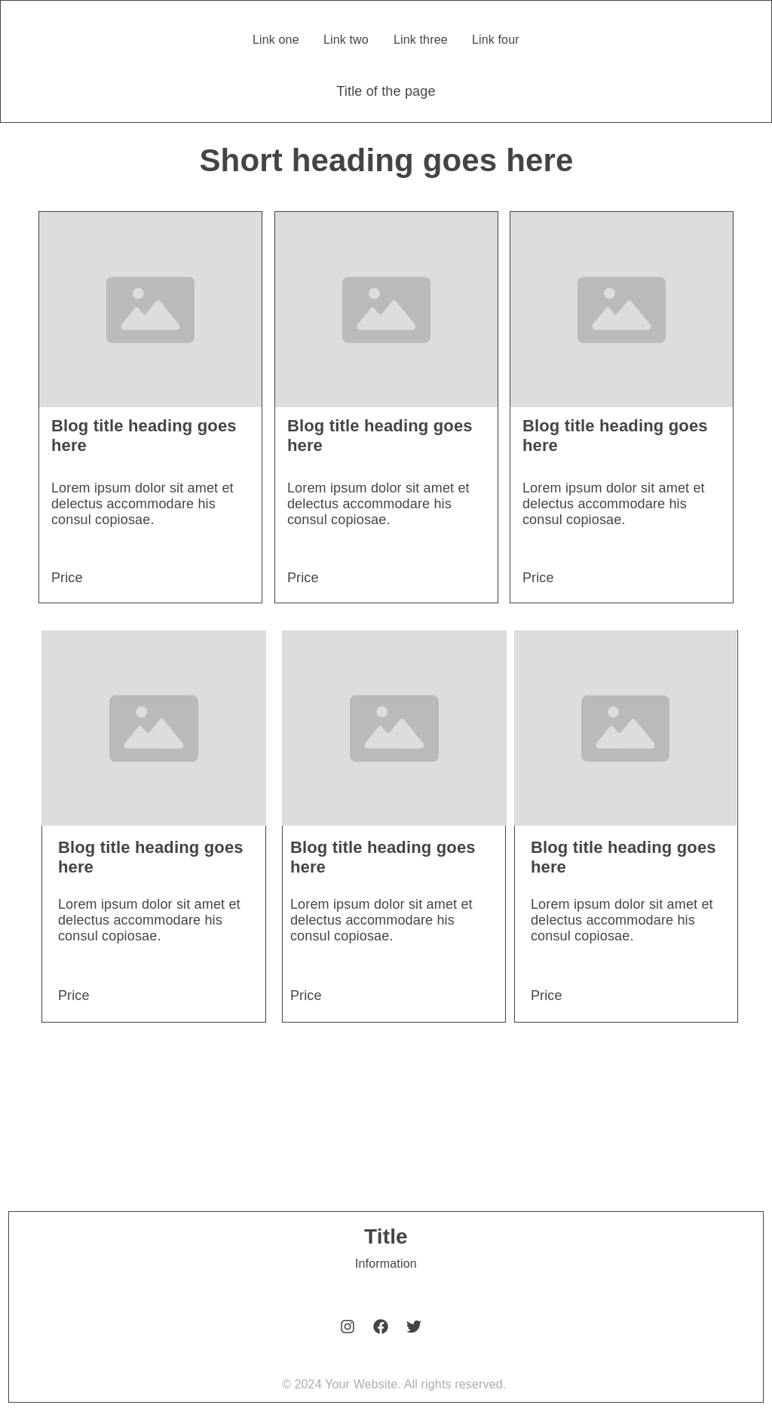

### Our Stores



### About Us

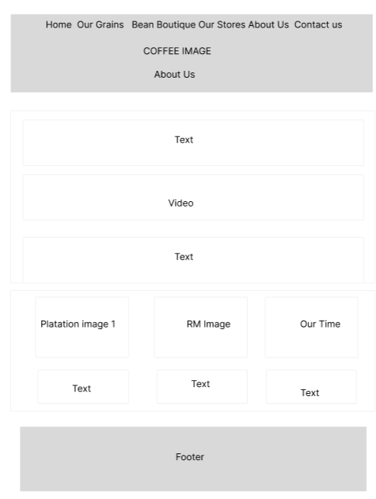

### Contact Us

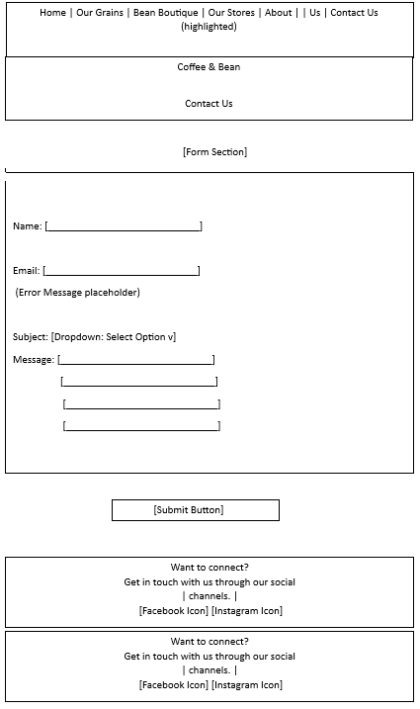

# Development

## Bootstrap

Bootstrap provides a robust, responsive framework that accelerates the development process while ensuring a cohesive and consistent design across the website. By leveraging Bootstrap, the project benefits in several keyways:

* Increased productivity: Ready-made components reduce the need for custom coding.
* Guaranteed responsiveness: Ensures the website is mobile-friendly and adapts seamlessly to various screen sizes.
* Cross-browser compatibility: Addresses inconsistencies across different web browsers.

In this project, Bootstrap has been implemented to deliver responsive layouts and stylized components efficiently, enabling faster development and a polished, user-friendly design.

Example of code where we applied bootstrap:

<div class="col">

<div class="card h-100">

<img src="images/colombian-coffee-beans-guide.jpg" class="card-img-top"

alt="Colombian Coffee">

<div class="card-body">

<h5 class="card-title">Colombian Coffee</h5>

<p class="card-text">

Colombia ranks among the top coffee producers worldwide, with beans known for their balanced flavours, medium body, and bright acidity. Colombian coffee offers diverse taste profiles, often featuring smooth notes of caramel, citrus, and chocolate.

</p>

</div>

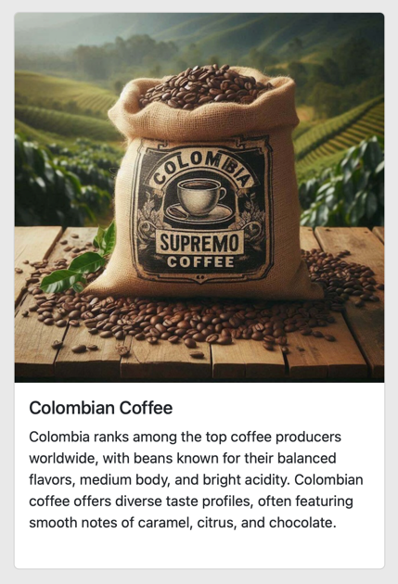 </div>

</div>

## jQuery

jQuery is a lightweight JavaScript library that simplifies HTML DOM manipulation, event handling, and animations, enhancing interactivity and user experience on a website. Its simplicity and cross-browser compatibility make it an excellent choice for web development, especially when implementing interactive features efficiently.

In our project, jQuery was utilized to enhance the responsiveness and usability of the website’s navigation menu, particularly for mobile devices. To achieve this, we implemented the *jquery.scrollex* plugin, which provides a powerful way to trigger animations and actions based on scrolling behaviour.

The use of *jquery.scrollex* allowed us to create a dynamic menu that adapts seamlessly to the user’s scrolling actions, ensuring the menu:

* Remains accessible: Improves navigation in the mobile view by dynamically showing or hiding menu elements as needed.
* Improves performance: Optimizes mobile interactivity by focusing only on active sections of the page.

This implementation ensures that the navigation menu delivers a clean and user-friendly experience, aligning with modern design standards and the responsive nature of the website.

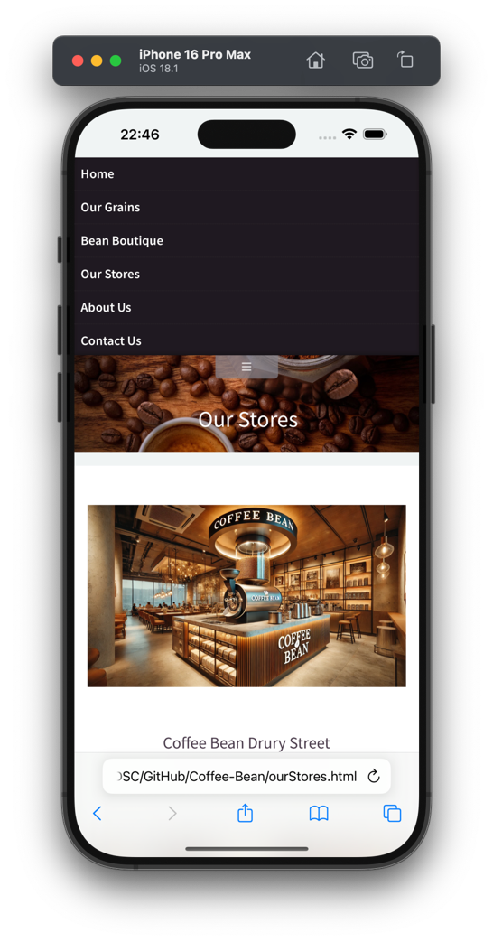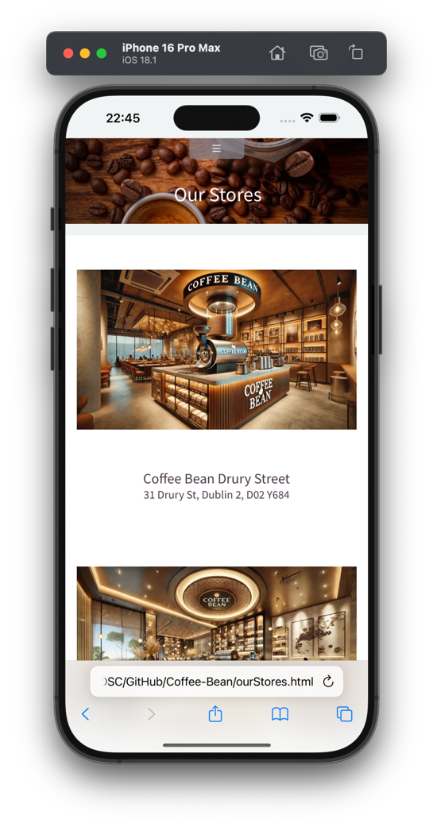

## JavaScript

JavaScript enhances the website’s interactivity, particularly through form **validation** on the “Contact Us” page. This ensures users provide accurate information by offering real-time feedback and highlighting errors, improving the overall user experience.

To help users locate the coffee shop, **we integrated Bing Maps**, featuring interactive navigation and a custom marker pinpointing the shop’s exact location. This addition improves the website’s utility and accessibility for visitors.

For product displays, we **leveraged Vue.js**, a progressive framework. Vue allowed us to efficiently build reusable, responsive product card components with minimal effort. Its reactivity ensures the cards update seamlessly when product data changes, streamlining the development process.

Together, these technologies optimized our website’s functionality, responsiveness, and user experience, aligning with modern web standards and ensuring a professional, engaging platform.

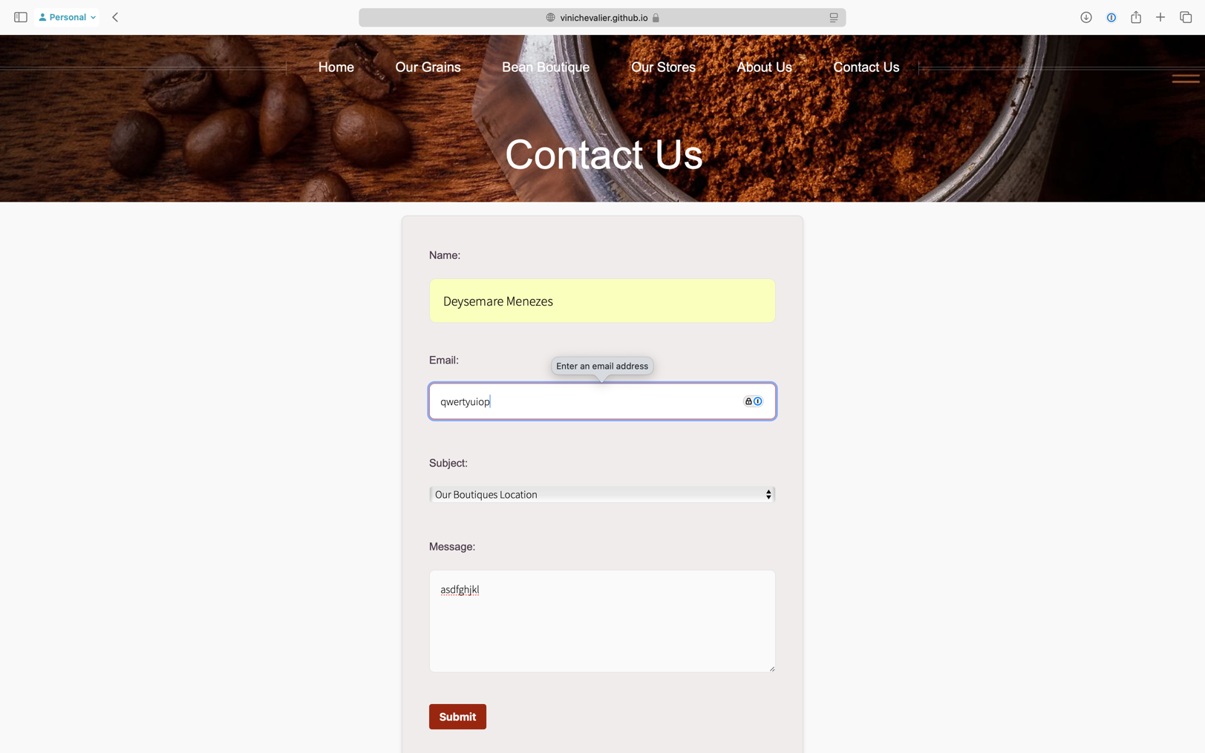

## Testing & Evidence

### HTML

Index

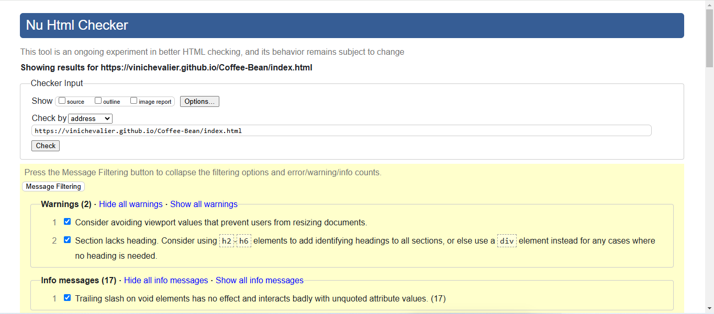

Our Grains

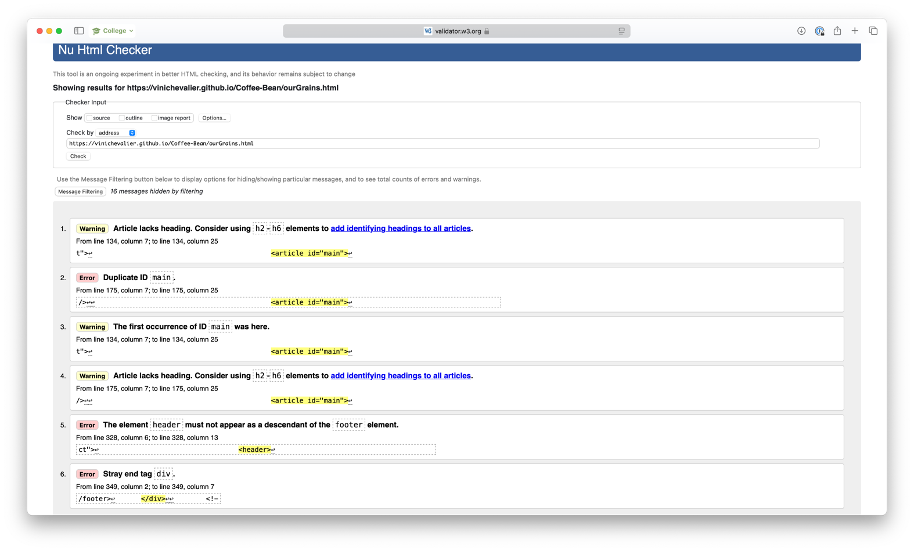

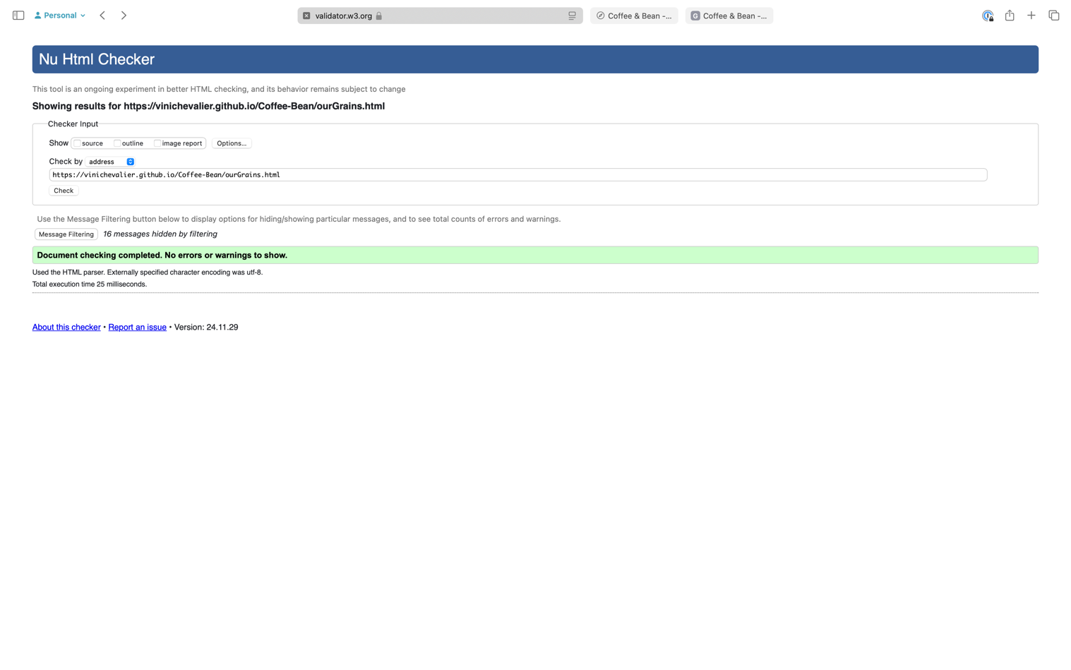

Bean Boutique

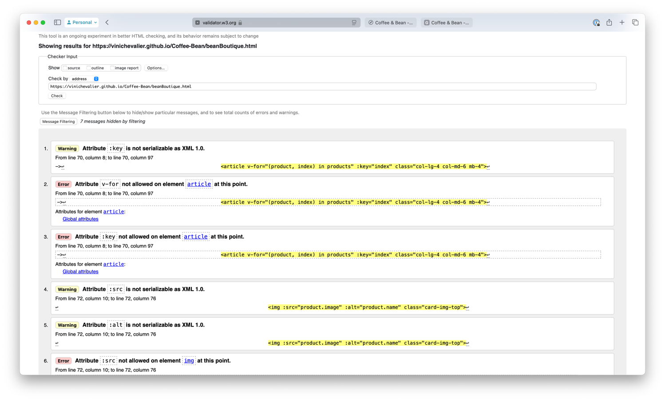

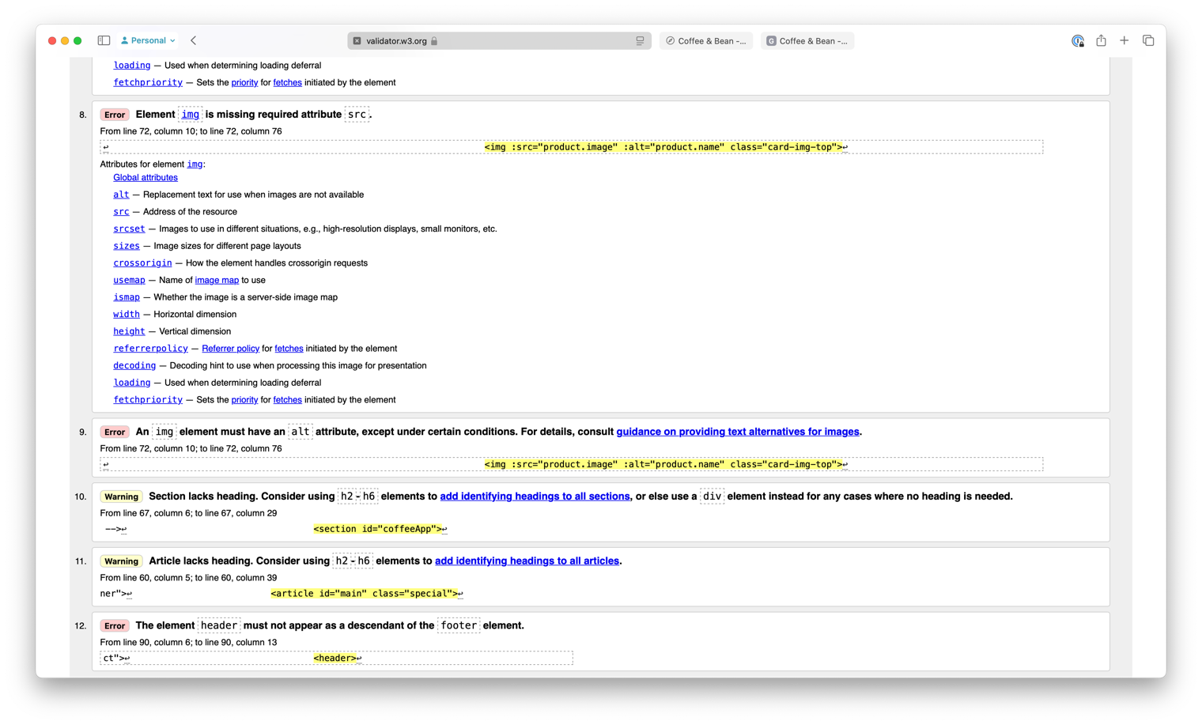

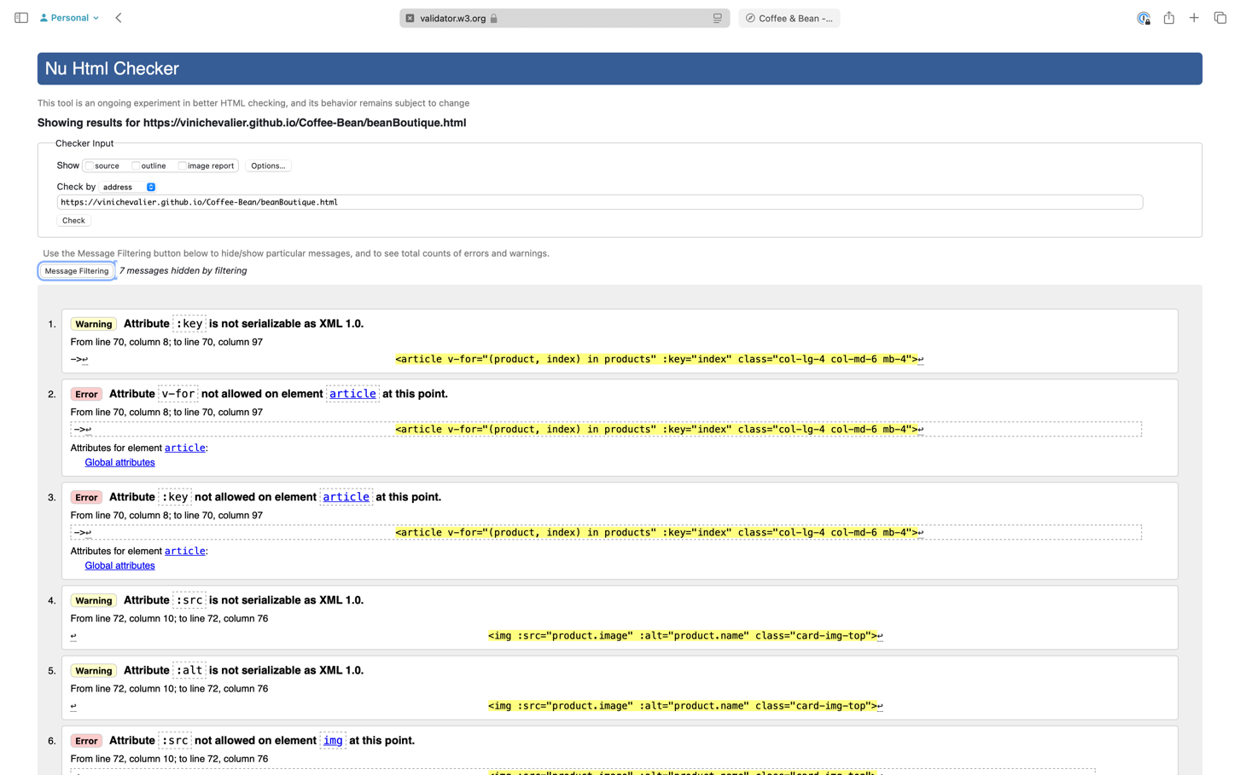

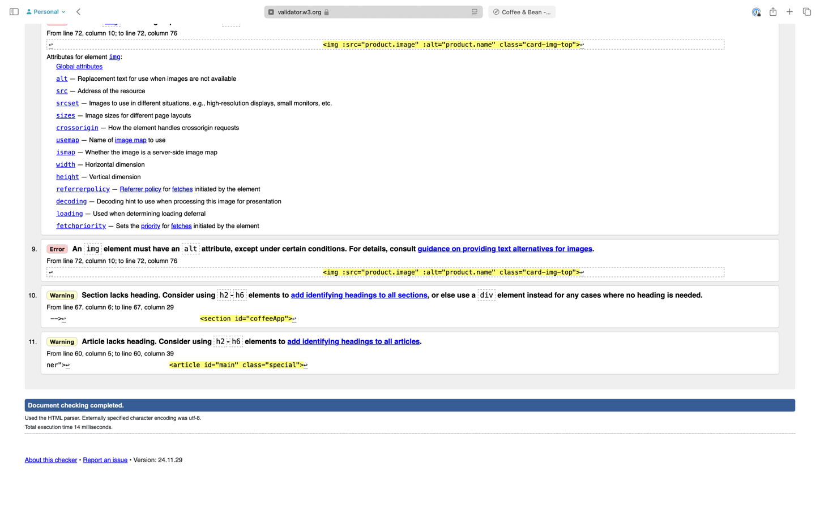

The error happens because validators only understand basic HTML. Vue.js adds special features to make the app dynamic, which browsers handle perfectly. We shouldn’t change it because it’s working as designed.

Our Stores

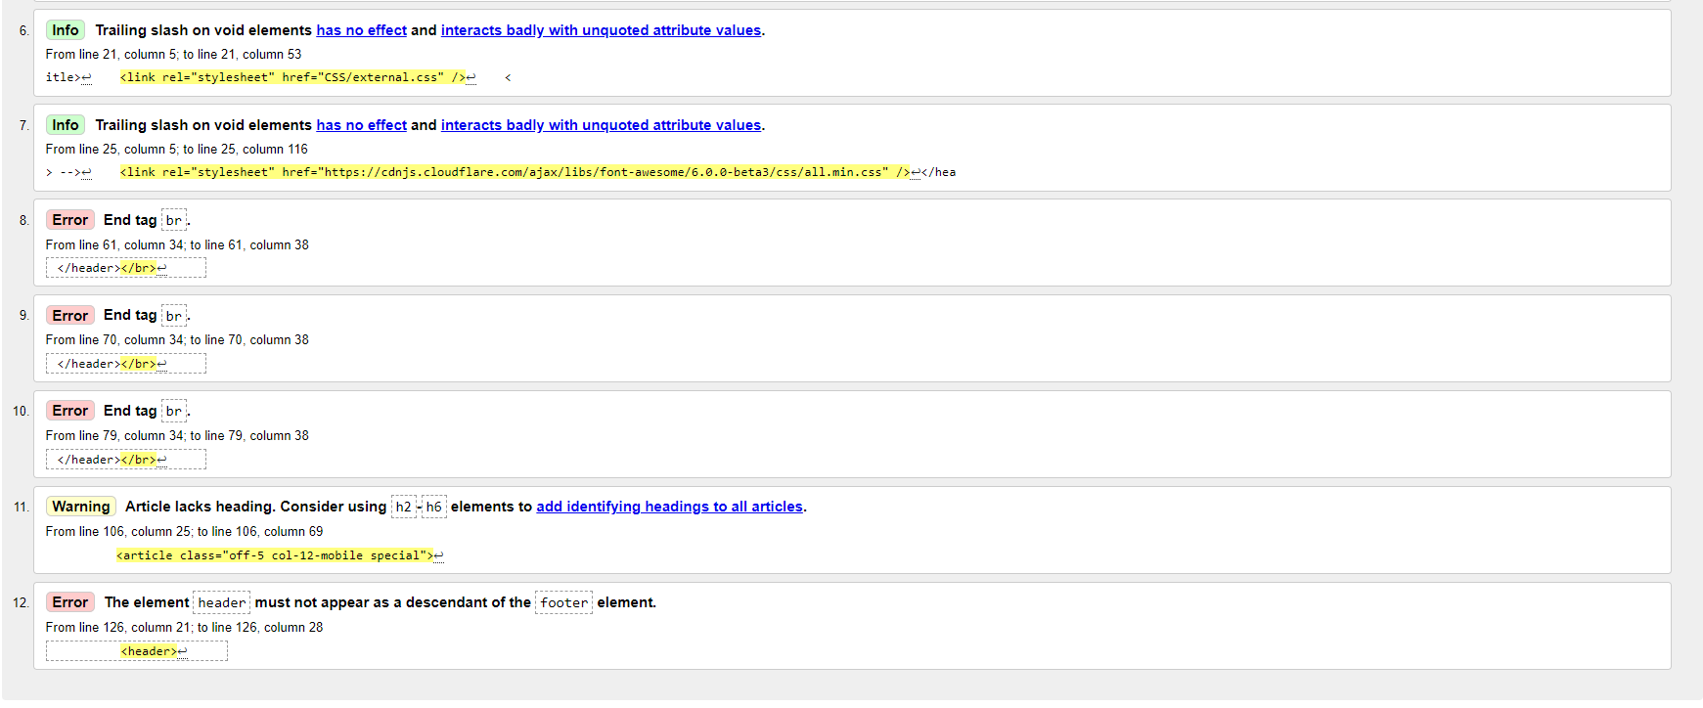

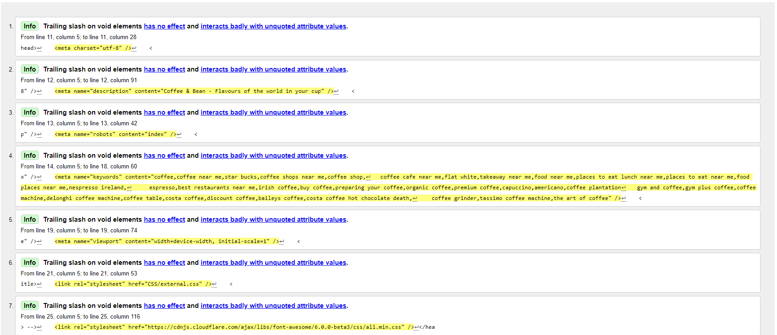

About Us

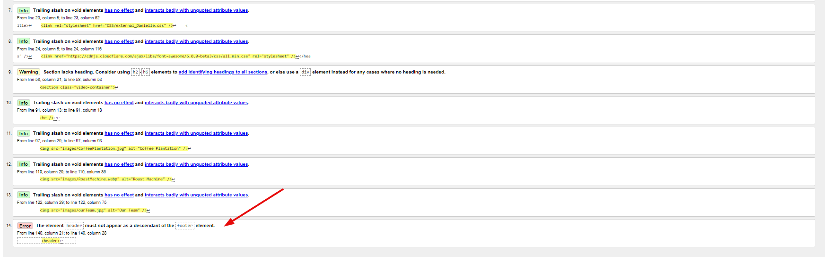

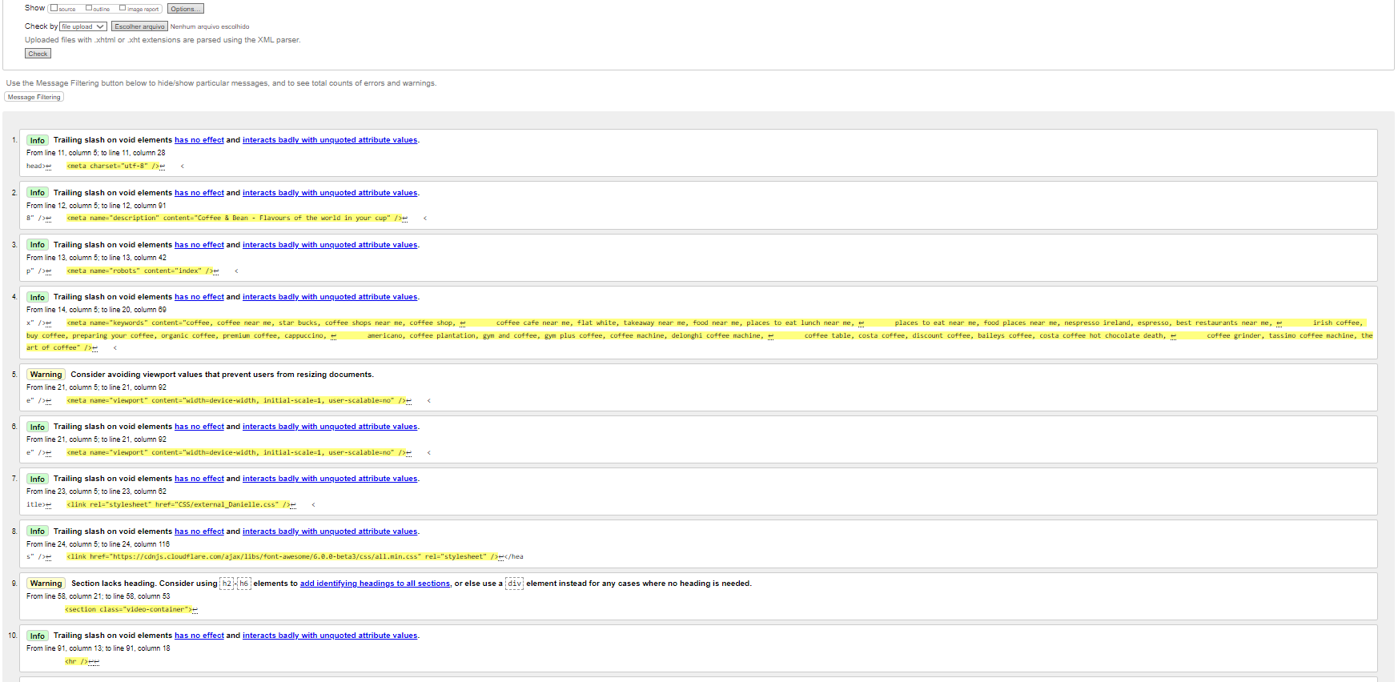

I



Contact Us

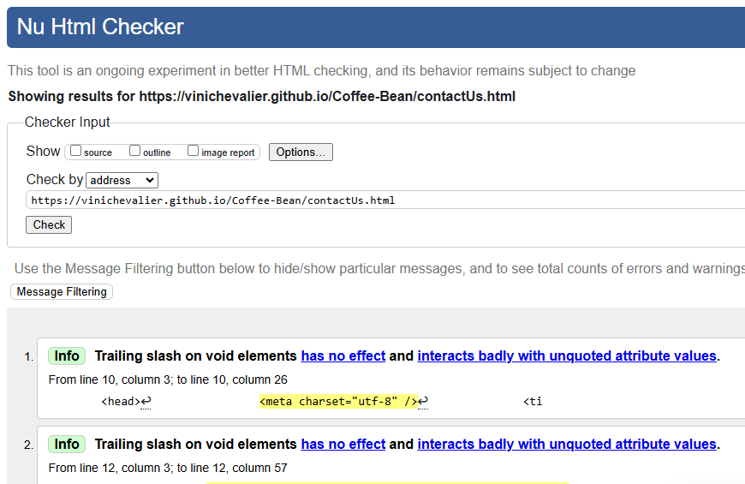



### CSS

Danielle:

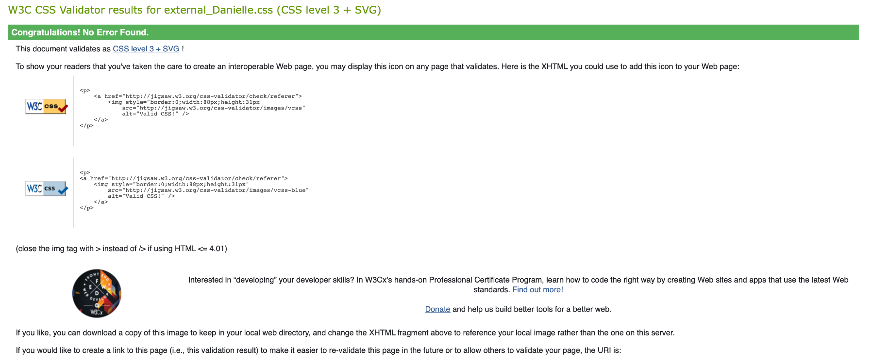

Deysemare:

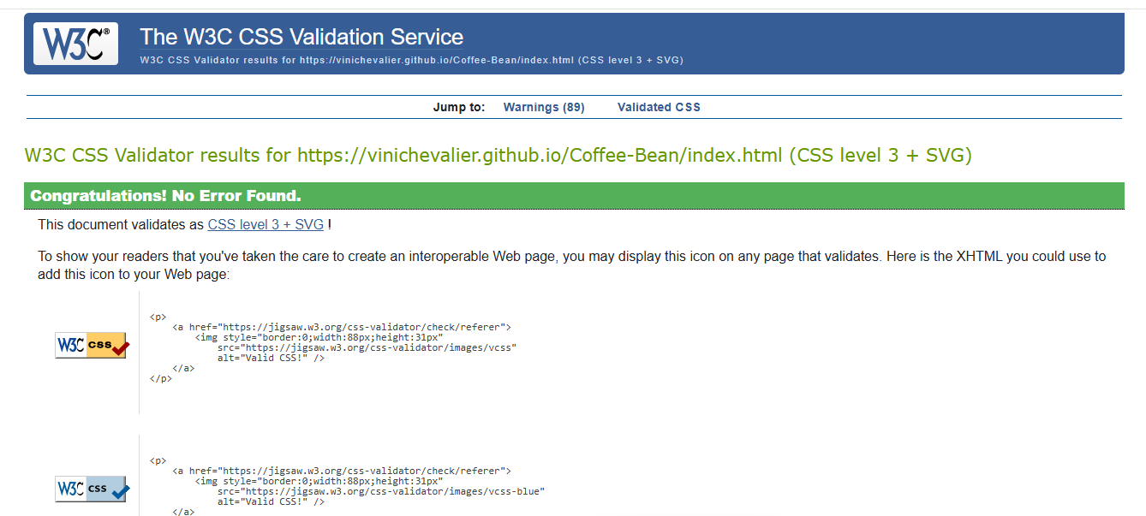

Vinícius:

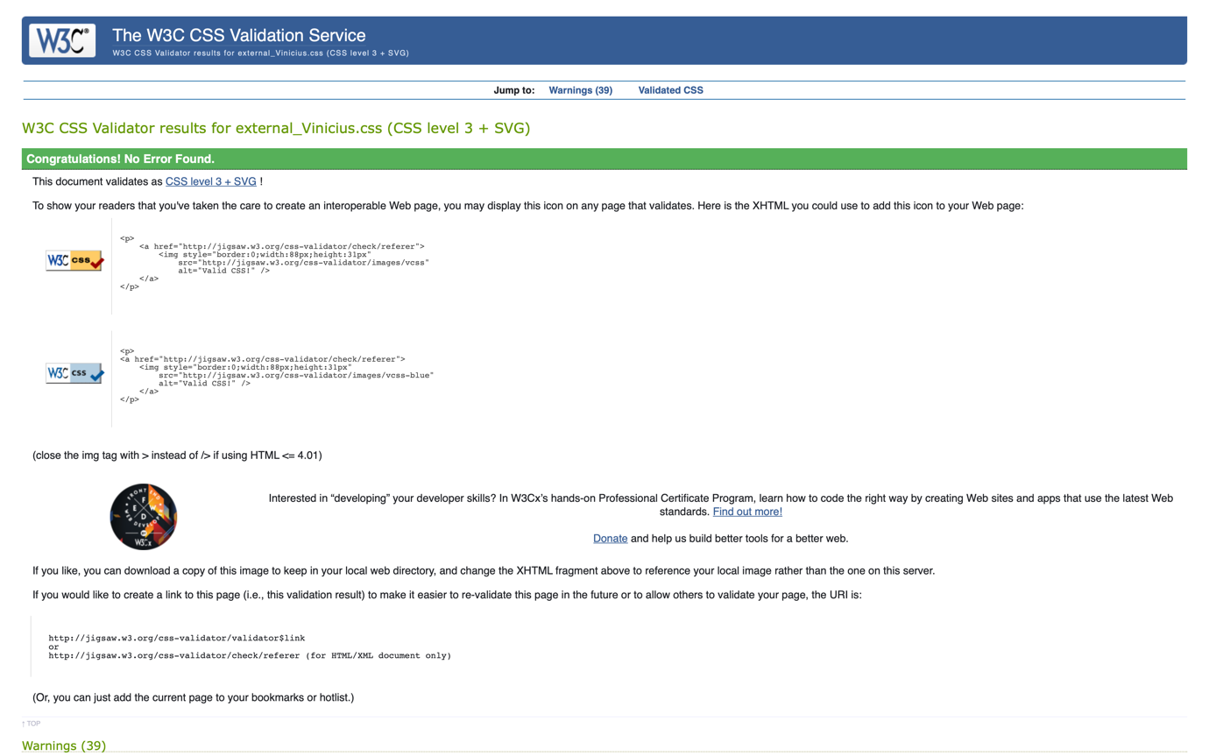

External_css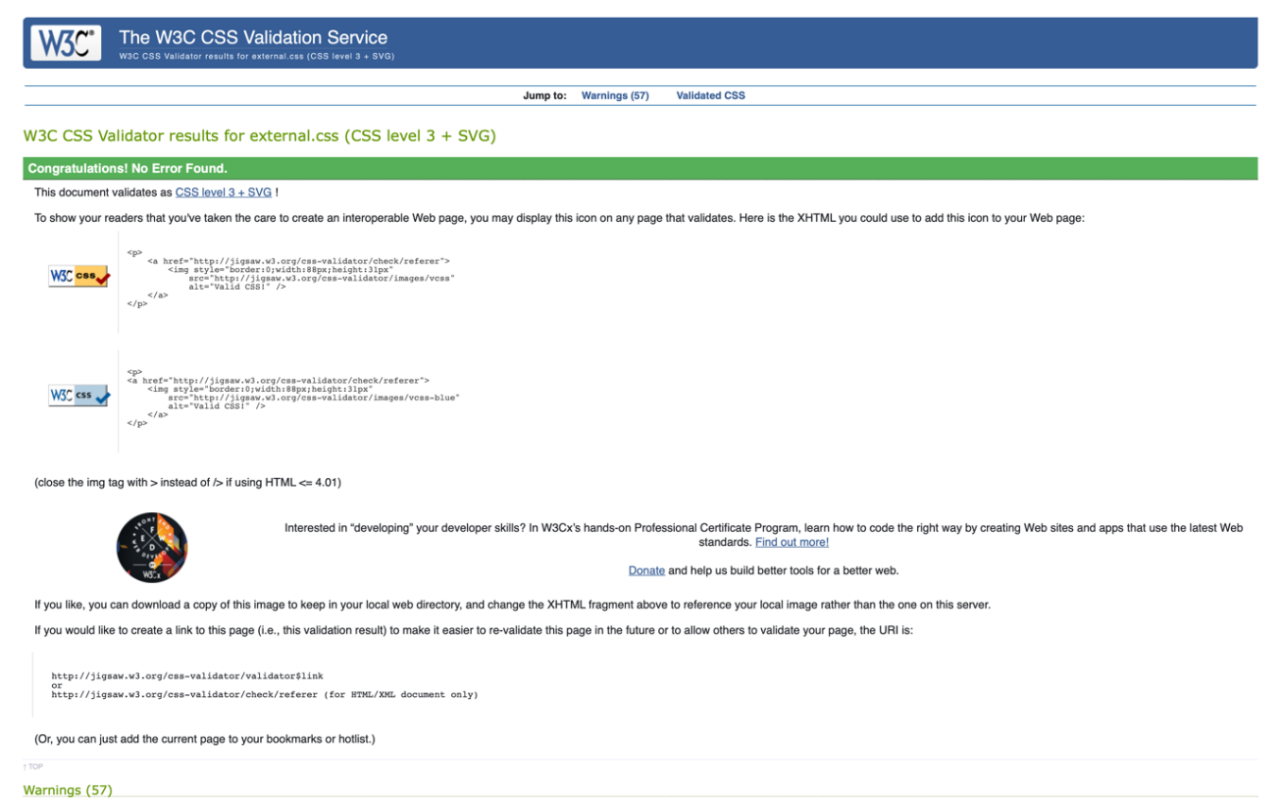

### Responsive Validation

Index

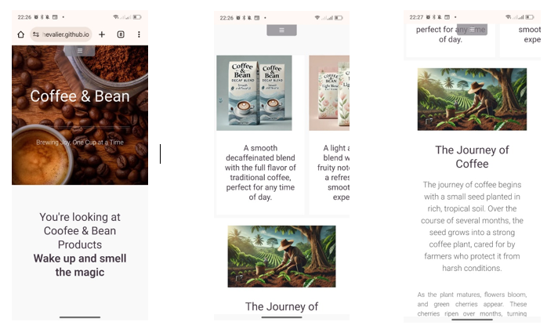

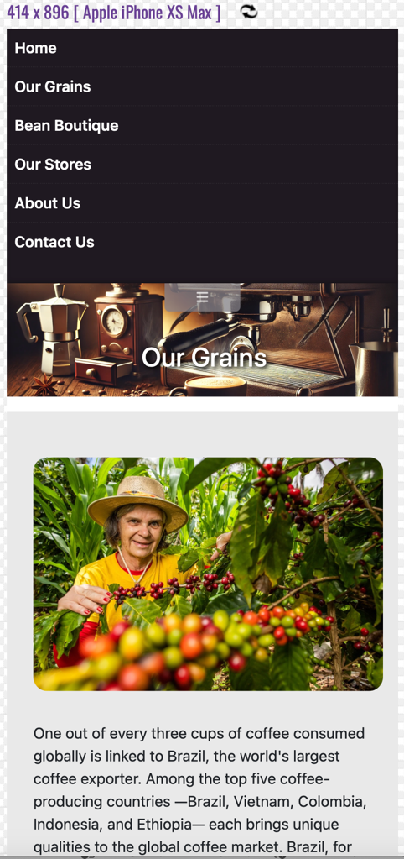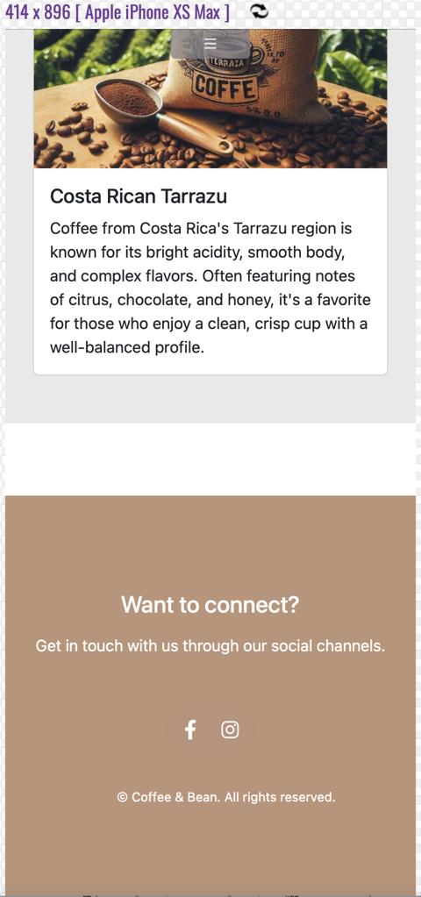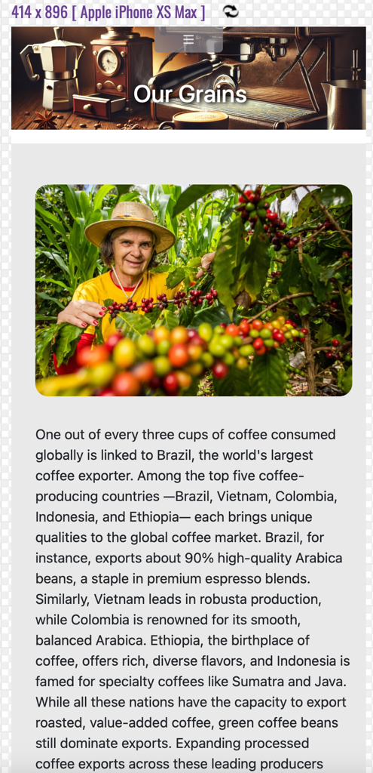Our Grains

Beans Boutique

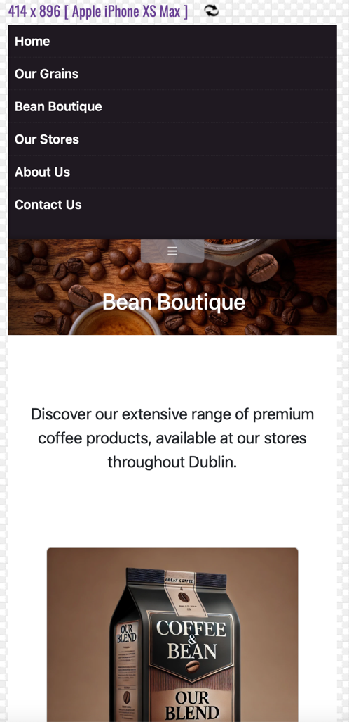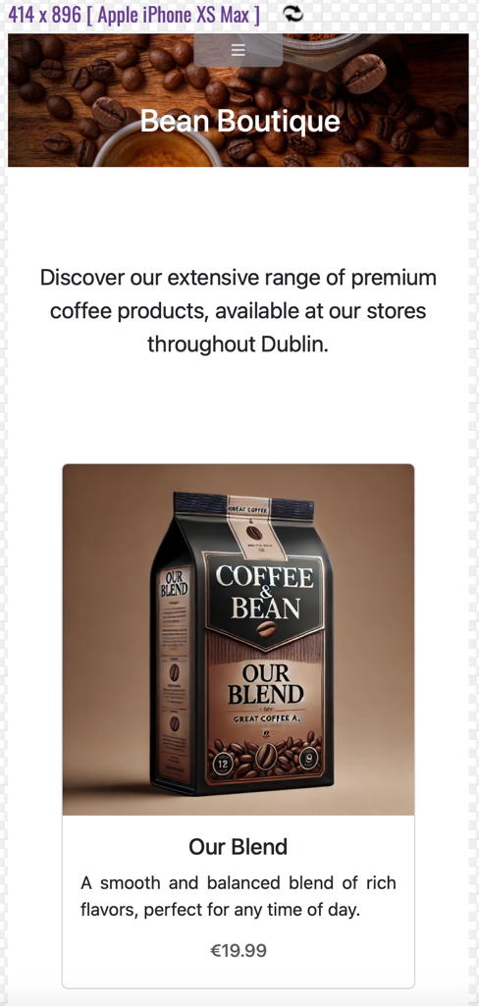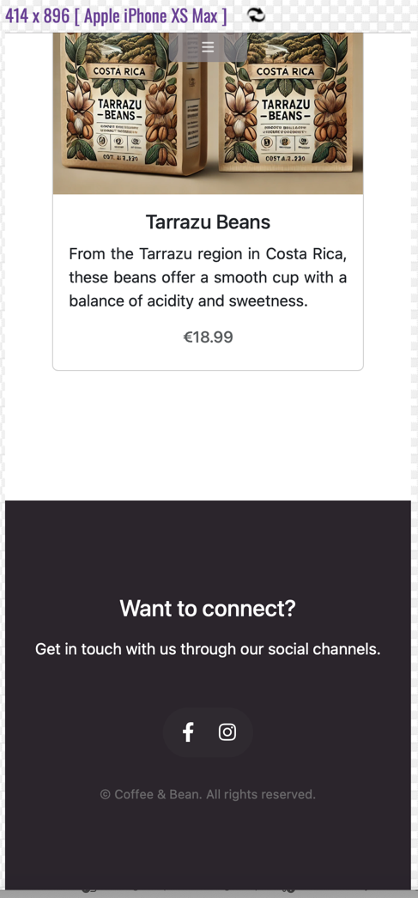

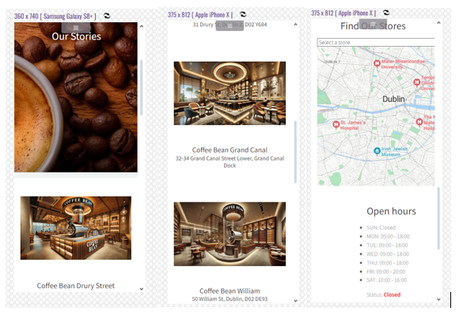Our Stores

About Us

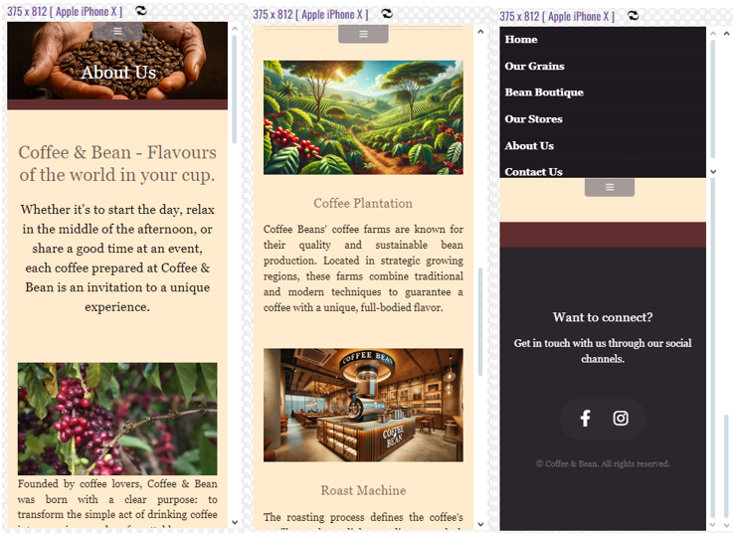

Contact Us

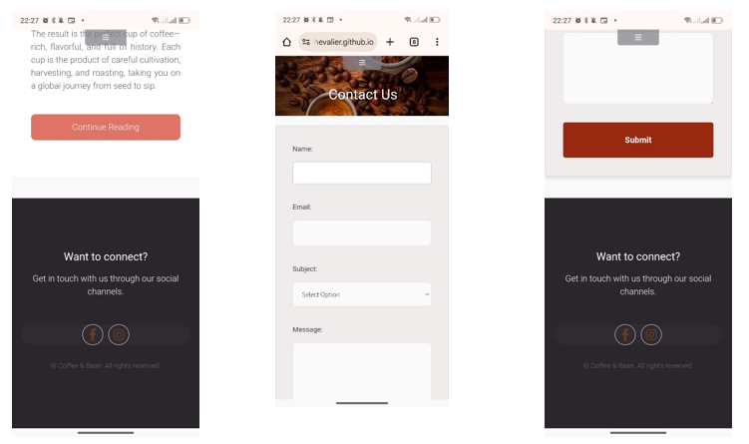

Validation performed on Desktop 1024x768.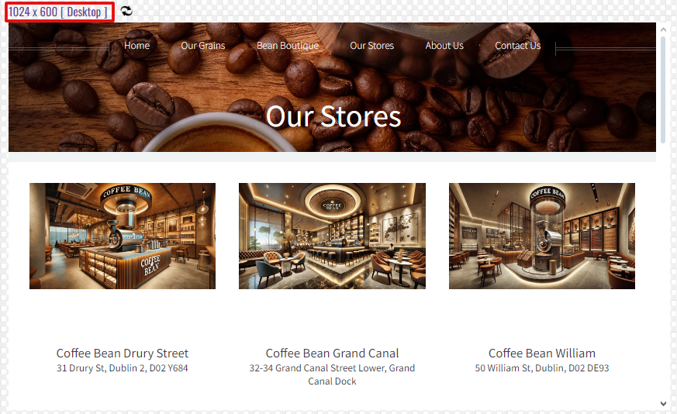

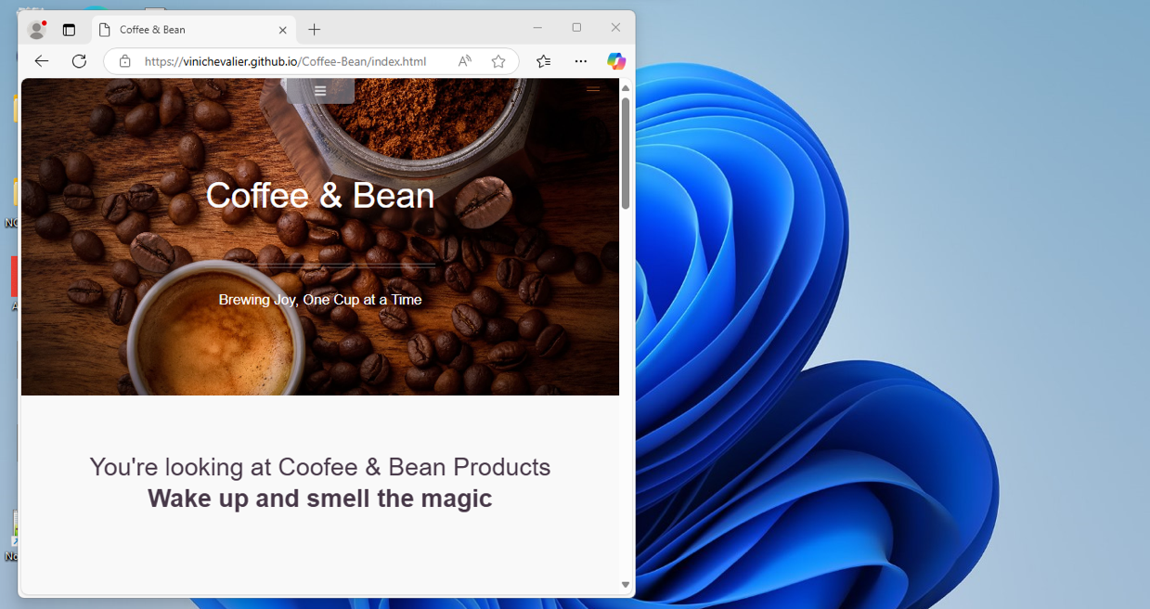Validation performed on Chrome Browser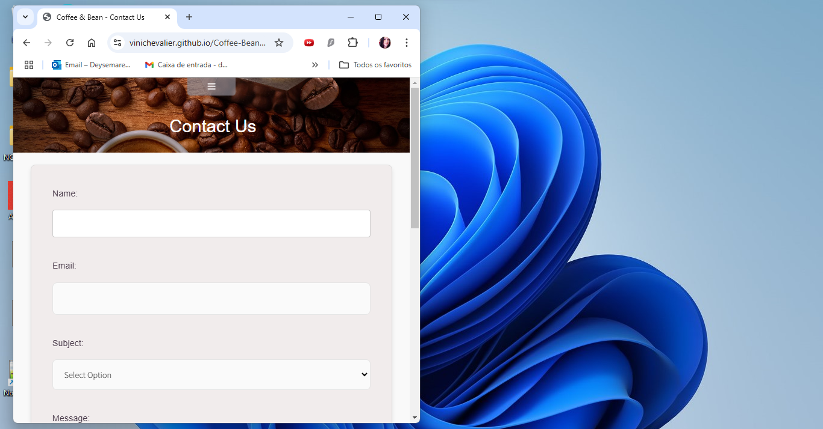Validation performed on Edge

### Speed Validation

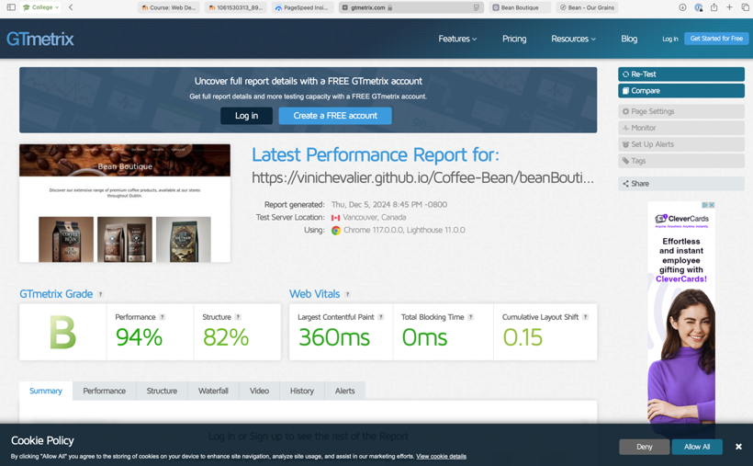

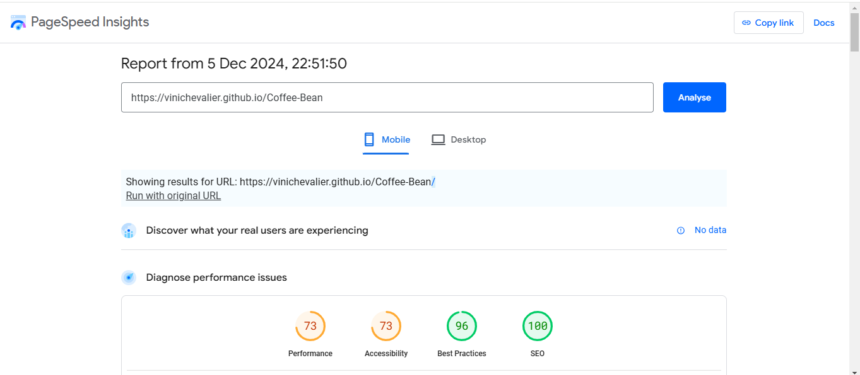

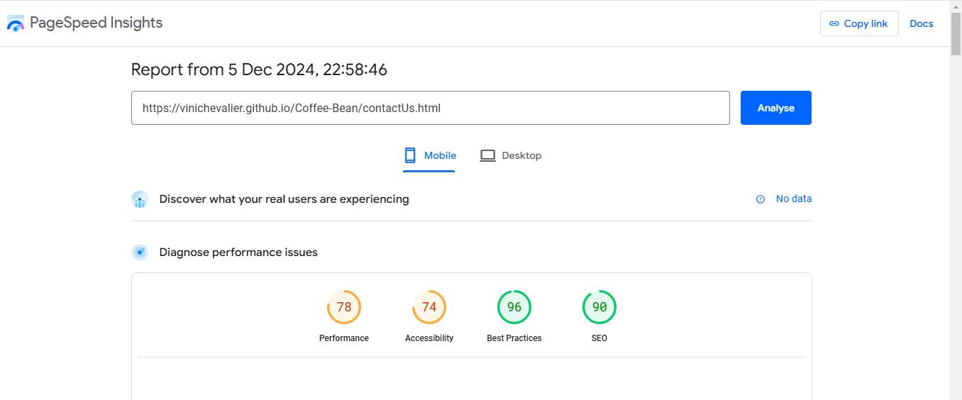

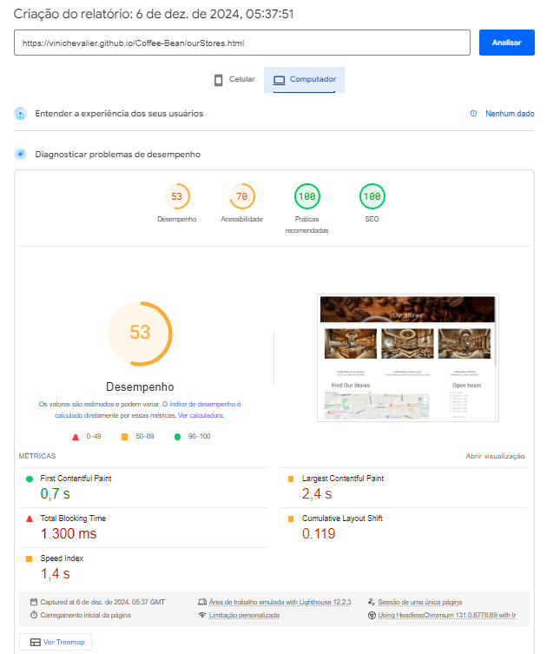

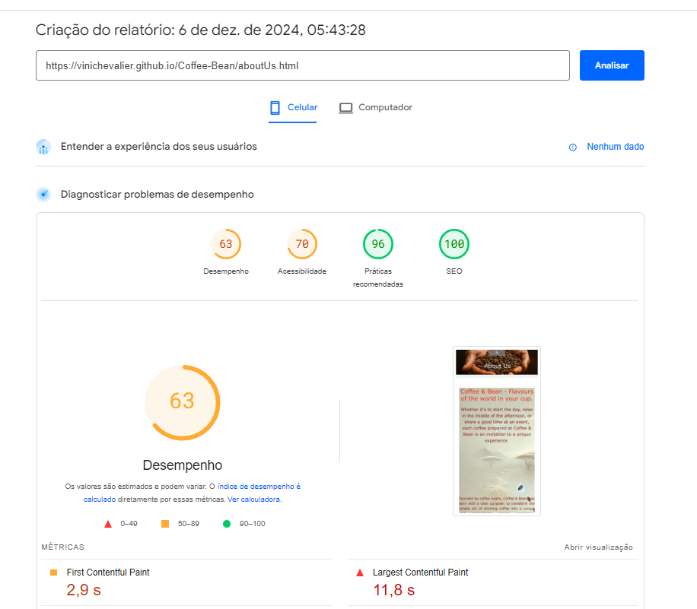

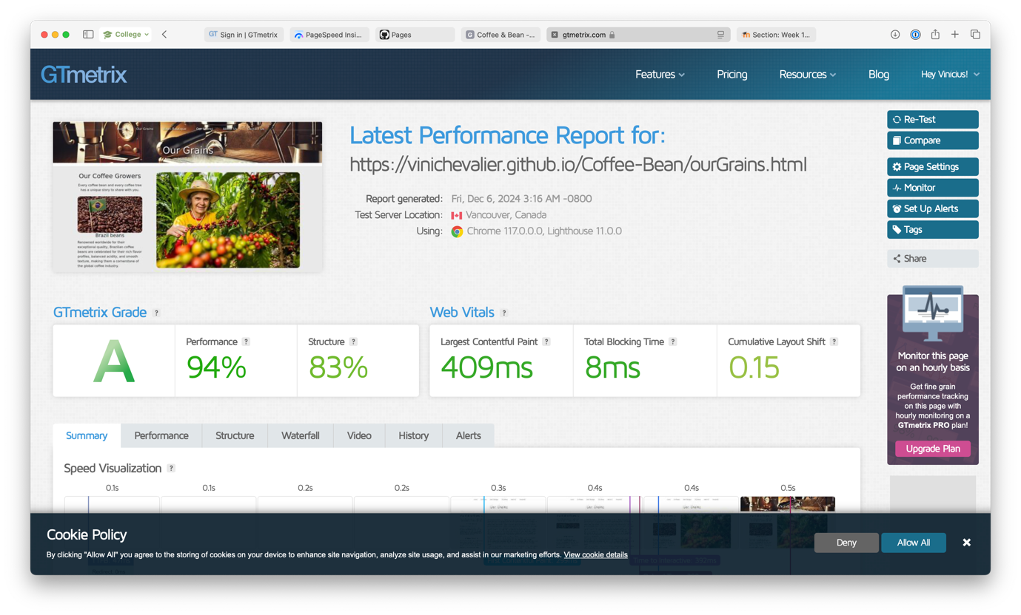

# A screenshot of a chat Description automatically generatedReviews

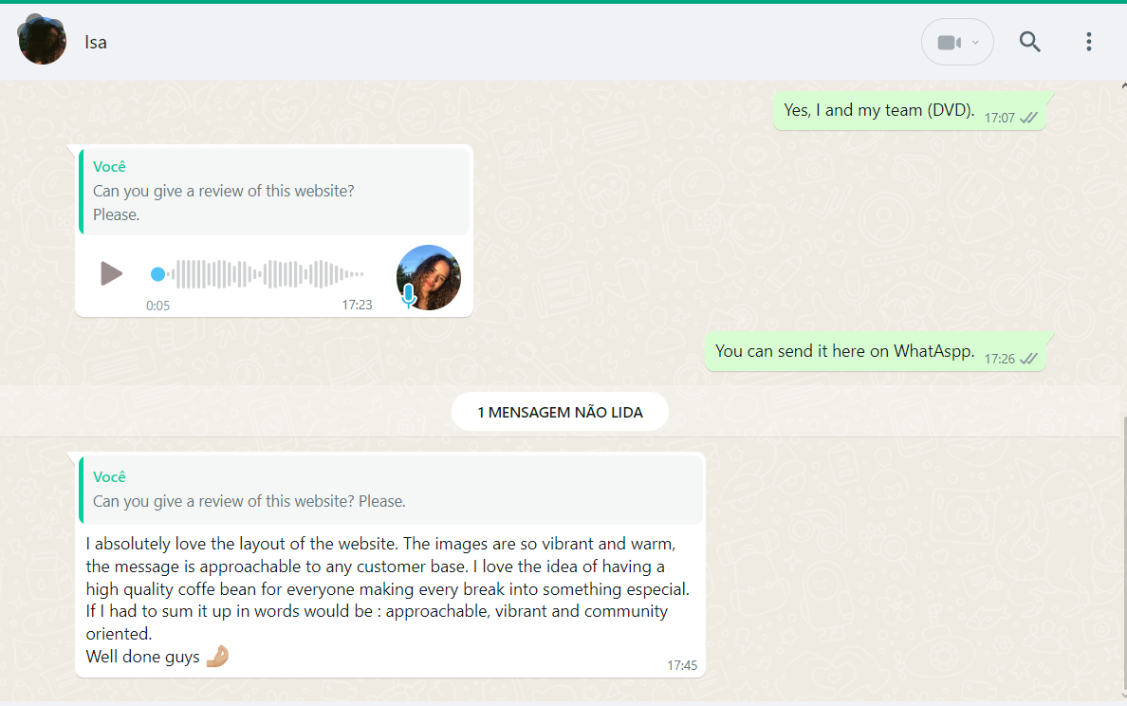

# Conclusion

The Coffee & Bean project exemplifies a successful collaboration between team members, blending creativity, technical expertise, and a shared passion for coffee culture. By identifying a gap in providing an engaging, user-friendly platform for coffee enthusiasts, we designed and implemented a website that bridges this gap while showcasing the rich history and significance of coffee.

Throughout the process, we applied industry-standard tools and methodologies, including Bootstrap for responsive design, jQuery for interactivity, and JavaScript for functionality enhancements. The integration of features like real-time form validation, dynamic navigation, and a visually cohesive design highlights our dedication to creating a seamless user experience.

Moreover, our teamwork was instrumental in overcoming challenges, ensuring consistent styling, debugging, and meeting deadlines through effective task distribution and communication. This project provided valuable insights into modern web development practices and reinforced the importance of user-centric design in creating impactful digital solutions.

The final website not only reflects our technical skills but also embodies our commitment to innovation and quality. We are proud to have created a platform that invites users into the world of coffee while meeting the project’s objectives and adhering to the principles of effective web design.

# References

* Bing Maps, 2024. Bing Maps API. Available at: https://www.bingmapsportal.com [Accessed 21 November 2024].
* Bootstrap, 2024. Bootstrap Framework: Documentation. Available at: https://getbootstrap.com/docs/ [Accessed 22 November 2024].
* BrewSmartly, 2024. The Coffee Obsession in Dublin: A Market Analysis. Available at: https://www.brewsmartly.com/dublin-coffee-market [Accessed 21 November 2024].
* Cool Hand Coffee Roasters, 2024. Coffee Roasting & Specialty Coffee. Available at: https://coolhandcoffeeroasters.ie [Accessed 29 November 2024].
* GitHub, 2024. GitHub: Where the world builds software. Available at: https://github.com/ [Accessed 18 November 2024].
* Google Fonts, 2024. Roboto Font. Available at: https://fonts.googleapis.com/css2?family=Roboto:ital,wght@0,100;0,300;0,400;0,500;0,700;0,900;1,100;1,300;1,400;1,500;1,700;1,900&display=swap [Accessed 03 December 2024].
* jQuery, 2024. jQuery Documentation. Available at: https://jquery.com/ [Accessed 30 November 2024].
* jQuery Scrollex, 2024. jQuery.scrollex Plugin. Available at: https://github.com/ajlkn/jquery.scrollex [Accessed 29 November 2024].
* OpenAI, 2024. ChatGPT Terms of Use. Available at: https://openai.com/policies/terms-of-use [Accessed 29 November 2024].
* Trello, 2024. Trello: Organize anything with anyone, anywhere! Available at: https://trello.com [Accessed 25 November 2024].
* Visual Studio Code, 2024. Visual Studio Code Documentation. Available at: https://code.visualstudio.com/docs [Accessed 25 November 2024].
* Vue.js, 2024. Vue.js Documentation. Available at: https://vuejs.org/ [Accessed 21 November 2024].